**1)Pattern for INEURON**

public class ineuron {  
  
 public static void main(String args[])  
 {  
 int i, j;  
 for(i=1;i<=7;i++)  
 {if(i==1||i==7)  
 for(j=1;j<=7;j++)  
 {  
 if (j != 7)  
 System.*out*.print("* ");  
 else  
 System.*out*.print("*");  
 }  
 else  
 {  
 for(j=1;j<=6;j++)  
 System.*out*.print(" ");  
 System.*out*.print("*");  
 }  
 System.*out*.print(" ");  
 if(i==1||i==7)  
 {  
 System.*out*.print("*");  
 for (j = 1; j <= 11; j++)  
 System.*out*.print(" ");  
 System.*out*.print("*");  
 }  
 else  
 {  
 for (j = 1; j <= 6; j++)  
 System.*out*.print(" ");  
 System.*out*.print("*");  
 for (j = 1; j <= 2 * (i - 1) - 1; j++)  
 System.*out*.print(" ");  
 System.*out*.print("*");  
 for(j=11-2*(i-1);j>=1;j--)  
 System.*out*.print(" ");  
 System.*out*.print("*");  
 }  
 System.*out*.print(" ");  
 if(i==1||i==4||i==7)  
 for(j=1;j<=7;j++)  
 if(j!=7)  
 System.*out*.print("* ");  
 else  
 System.*out*.print("*");  
 else  
 System.*out*.print("*");  
 System.*out*.print(" ");  
  
 if(i!=7) {  
 if (i == 1 || i == 4)  
 {  
  
 System.*out*.print("*");  
 for (j = 1; j <= 11; j++) {  
 System.*out*.print(" ");  
 }  
  
 System.*out*.print("*");  
 }  
  
  
 else{  
 for (j = 1; j <= 12; j++)  
 System.*out*.print(" ");  
 System.*out*.print("*");  
 for (j = 1; j <= 11; j++) {  
 System.*out*.print(" ");  
 }  
  
 System.*out*.print("*");  
 }  
 }  
 else  
 {  
 for(j=1;j<=7;j++)  
 if(j!=7)  
 System.*out*.print("* ");  
 else  
 System.*out*.print("*");  
 }  
  
 System.*out*.print(" ");  
 if(i==1||i==4)  
 for(j=1;j<=4;j++)  
  
 if(j!=4)  
 System.*out*.print("* ");  
 else  
 System.*out*.print("* ");  
  
 else if(i==2||i==3)  
 {  
 System.*out*.print("*");  
 for (j = 1; j <= 7; j++)  
 System.*out*.print(" ");  
 System.*out*.print("*");  
 }  
 else  
 {  
 System.*out*.print("*");  
 for(j=1;j<=2*i-9;j++)  
 System.*out*.print(" ");  
 System.*out*.print("*");  
 for(j=2*i-7;j<=8;j++)  
 System.*out*.print(" ");  
  
 }  
 System.*out*.print(" ");  
 if(i==1||i==7)  
 for(j=1;j<=7;j++)  
 if(j!=7)  
 System.*out*.print("* ");  
 else  
 System.*out*.print("*");  
 else  
 {  
 System.*out*.print("*");  
 for(j=1;j<=11;j++)  
 System.*out*.print(" ");  
 System.*out*.print("*");  
 }  
  
 System.*out*.print(" ");  
 if(i==1||i==7)  
 {  
 System.*out*.print("*");  
 for (j = 1; j <= 11; j++)  
 System.*out*.print(" ");  
 System.*out*.print("*");  
 }  
 else  
 {  
  
 System.*out*.print("*");  
 for (j = 1; j <= 2 * (i - 1) - 1; j++)  
 System.*out*.print(" ");  
 System.*out*.print("*");  
 for(j=11-2*(i-1);j>=1;j--)  
 System.*out*.print(" ");  
 System.*out*.print("*");  
 }  
 System.*out*.println();  
 }  
 }  
}

OUTPUT:

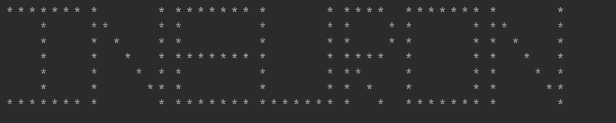

**2) Write a program to print Pattern 1 1 1 1**

**2 2 2 2**

**3 3 3 3**

**4 4 4 4**

import java.util.Scanner;  
  
public class pattern5 {  
 public static void main(String[] args)  
 {  
 Scanner sc = new Scanner(System.*in*);  
  
 int n = sc.nextInt();  
 for(int i=1;i<n;i++)  
 {  
 for(int j=1;j<n;j++)  
 {  
 System.*out*.print(" " +i );  
 }  
 System.*out*.println();  
 }  
 System.*out*.println();  
 }  
}

**Output:**

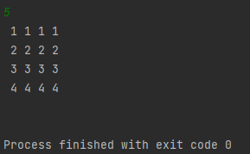

**3) Write a program to print pattern**

import java.util.Scanner;  
  
public class pattern6 {  
 public static void main(String[] args)  
 {  
 Scanner sc= new Scanner(System.*in*);  
 int n=sc.nextInt();  
 {  
 for(int i=0;i<n;i++)  
 {  
 for(int j=0;j<n;j++)  
 {  
 if(i==0 || j==0 || i==n-1 || j==n-1 || i+j<=(n-2)/2 || j-i>=(n-2)/2)  
 System.*out*.print("*");  
 else  
 System.*out*.print(" ");  
 }  
 System.*out*.println();  
 }  
 }  
  
 }  
}

**Output:**

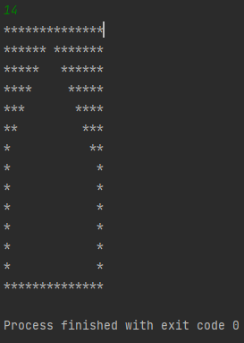

**4) Write a program to print pattern**

import java.util.Scanner;  
  
public class pattern7 {  
 public static void main(String[] args)  
 {  
 Scanner sc= new Scanner(System.*in*);  
 int n= sc.nextInt();  
 {  
 for(int i=0;i<n;i++)  
 {  
 for(int j=0;j<n;j++)  
 {  
 if(i==n-1 || i==n-2 || i-j >= (n-1)/2 || i+j>=n+5)  
 System.*out*.print("*");  
 else  
 System.*out*.print(" ");  
 }  
 System.*out*.println();  
 }  
 }  
 }  
}

**Output:**

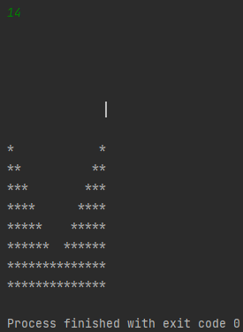

**5) Write a program to print pattern**

import java.util.Scanner;  
  
public class pattern8 {  
 public static void main(String[] args)  
 {  
 Scanner sc= new Scanner(System.*in*);  
 int n= sc.nextInt();  
 {  
 for(int i=0;i<n;i++)  
 {  
 for(int j=0;j<n;j++)  
 {  
 if (i==0 || j==0 || i==n-1 || i+j<=(n-2)/2 || i-j>=(n-2)/2)  
 System.*out*.print("*");  
 else  
 System.*out*.print(" ");  
 }  
 System.*out*.println();  
 }  
 }  
  
 }  
  
}

**Output:**

